# Smart Personal Finance Manager User Manual

## 1. Software Overview

Smart Personal Finance Manager is a financial management software designed for individuals. It helps you manage your personal finances efficiently, covering the recording and analysis of income, expenses, budgets, etc., enabling you to easily keep track of your financial situation.

## 2. Interface Introduction

### (1) Menu Bar

1. **Dashboard**
   * **Home**: Displays a welcome message, as well as a consumption trend graph and a consumption structure pie chart for the past 7 days. The consumption trend graph allows you to visually see the changes in consumption amounts over time, and the consumption structure pie chart shows the proportion of various consumption categories.
   * 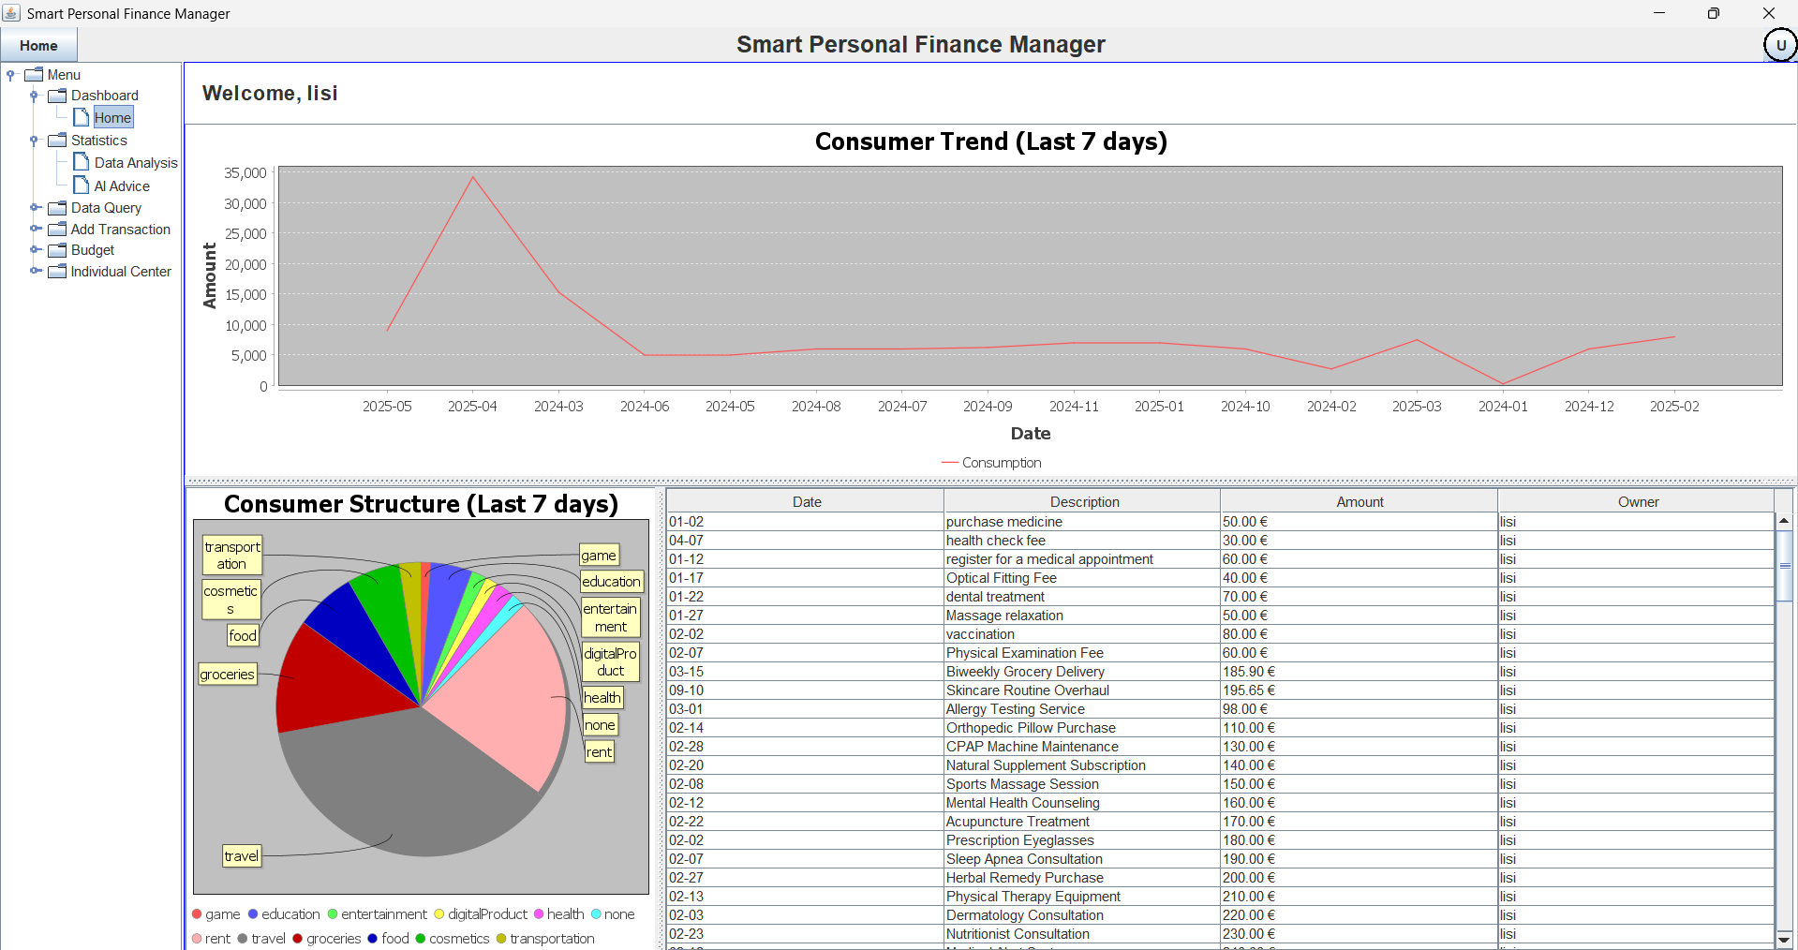
   * **Statistics**
     + **Data Analysis**: Provides expenditure ranking information, as well as bar chart displays of monthly income and expenses, helping you understand the distribution and trends of income and expenses.
     + 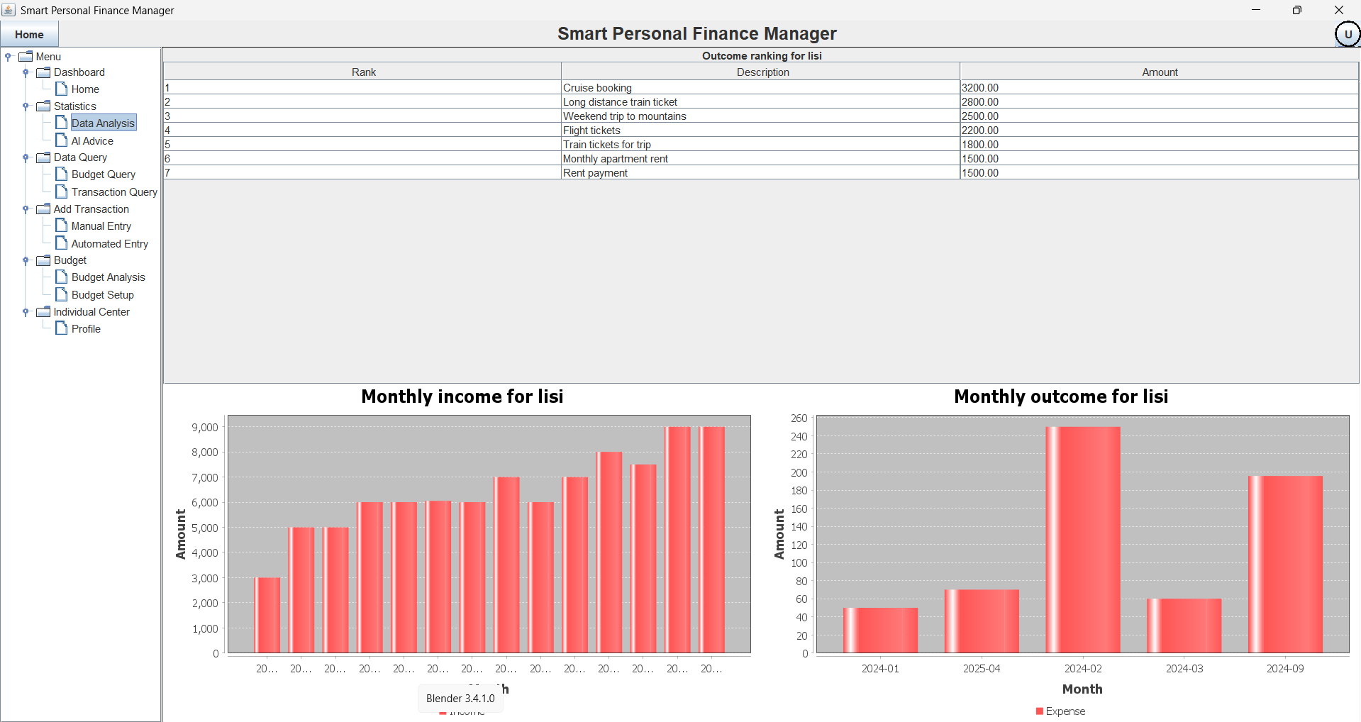
     + **AI Advice**: Generates general financial advice, budget analysis, consumption analysis, savings analysis, long - term financial analysis, and holiday spending advice based on your financial data.
     + 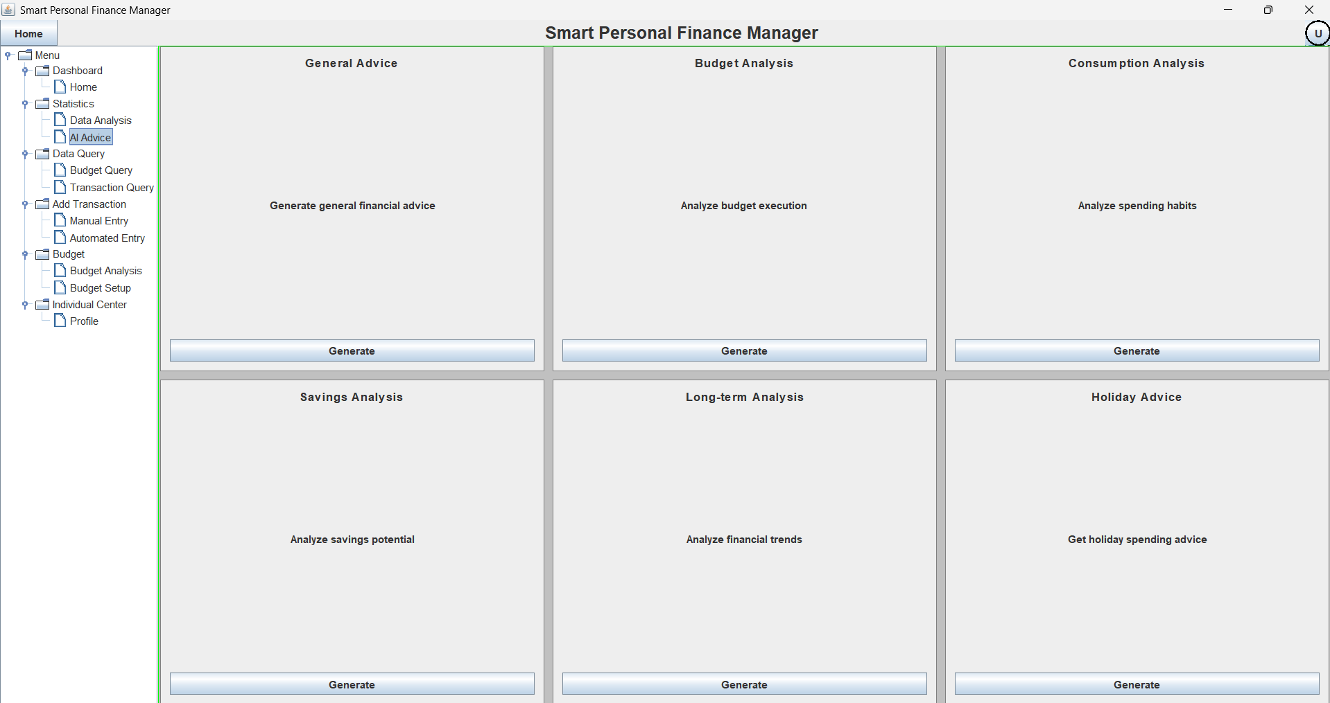
2. **Data Query**
   * **Budget Query**: Allows you to query budget - related records based on conditions such as budget ID, date, owner, and type.
   * 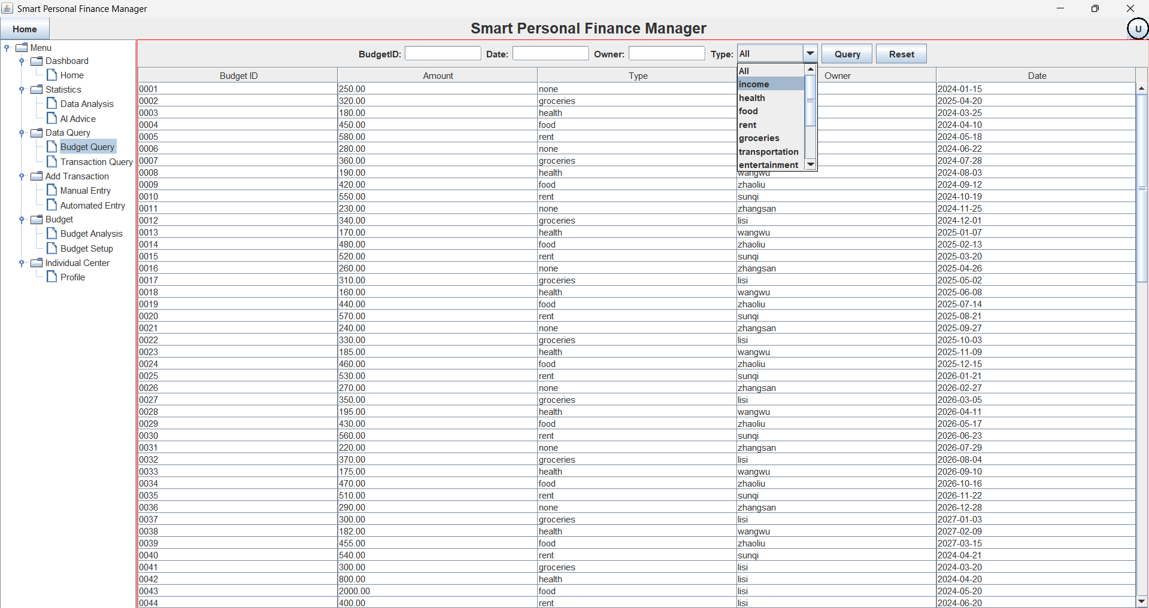
   * **Transaction Query**: Supports querying transaction records through conditions such as date, owner, location, and type, and also allows you to modify the transaction type.
   * 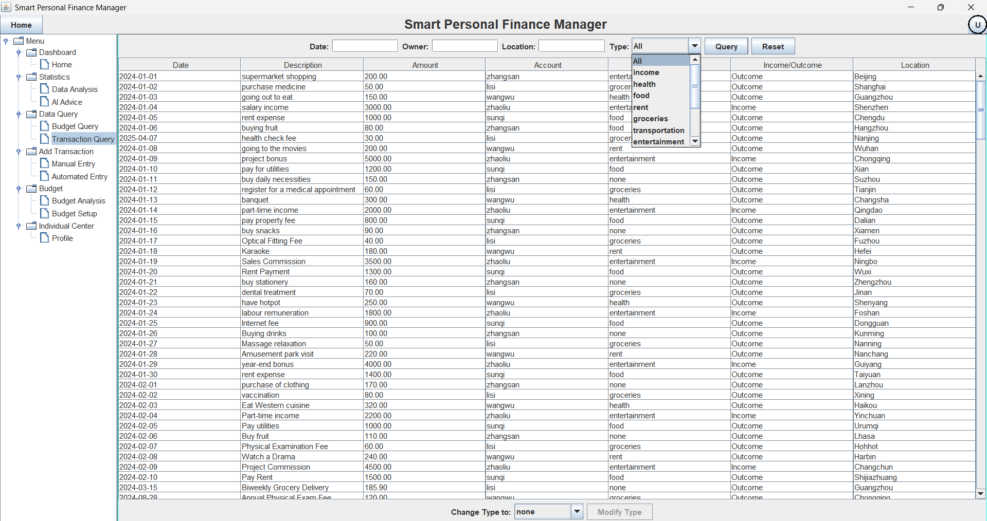
3. **Add Transaction**
   * **Manual Entry**: Manually enter transaction amount, type, time, product name, location, description, and other information.
   * 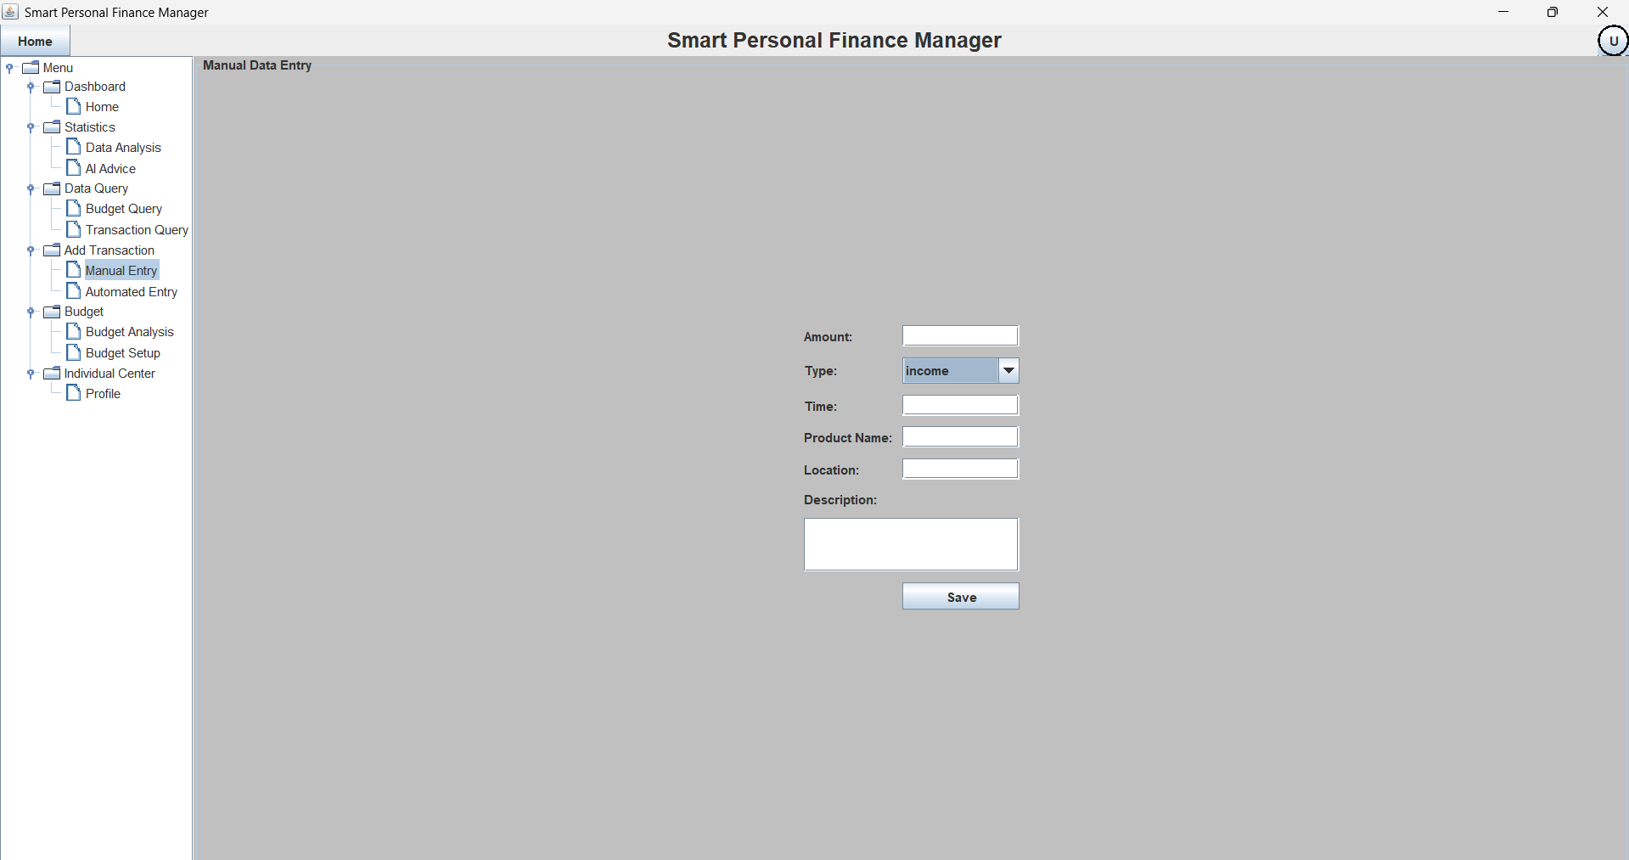
   * **Automated Entry**: Batch - import transaction data by uploading a CSV file.
   * 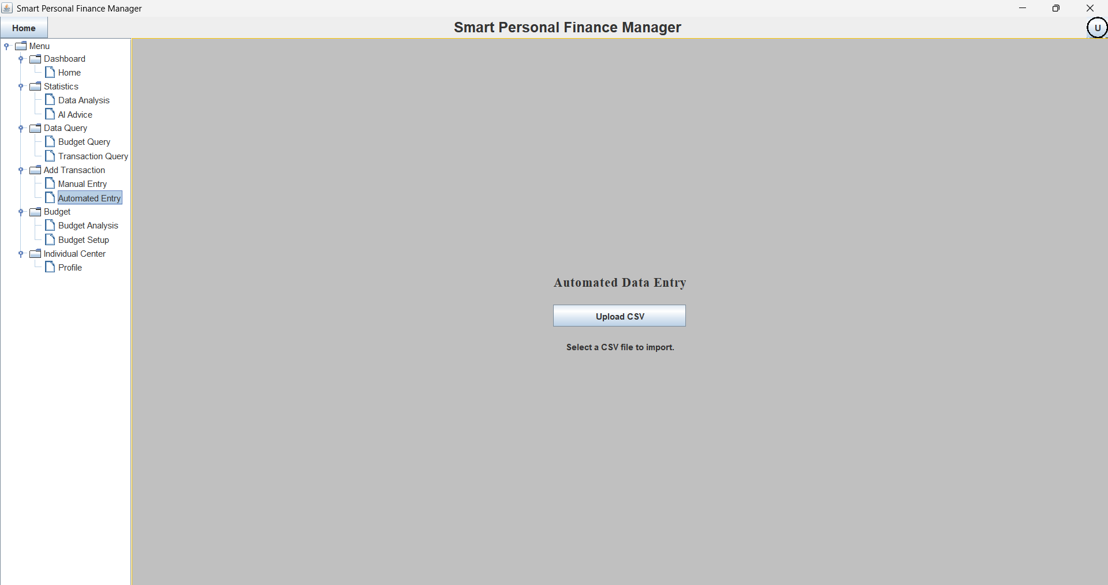
4. **Budget**
   * **Budget Analysis**: Presents historical budget comparison bar charts, budget distribution pie charts, and budget - vs - actual - expenditure comparison line charts, facilitating the analysis of budget execution.
   * 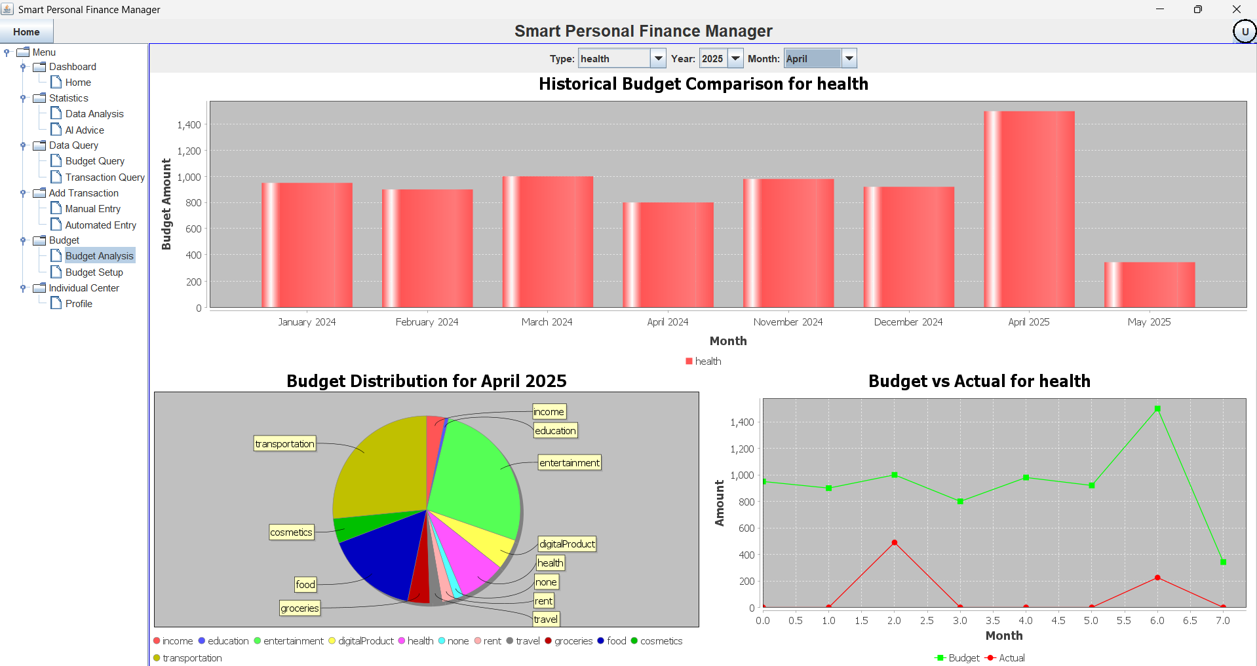
   * **Budget Setup**: Set the budget amount for each category.
   * 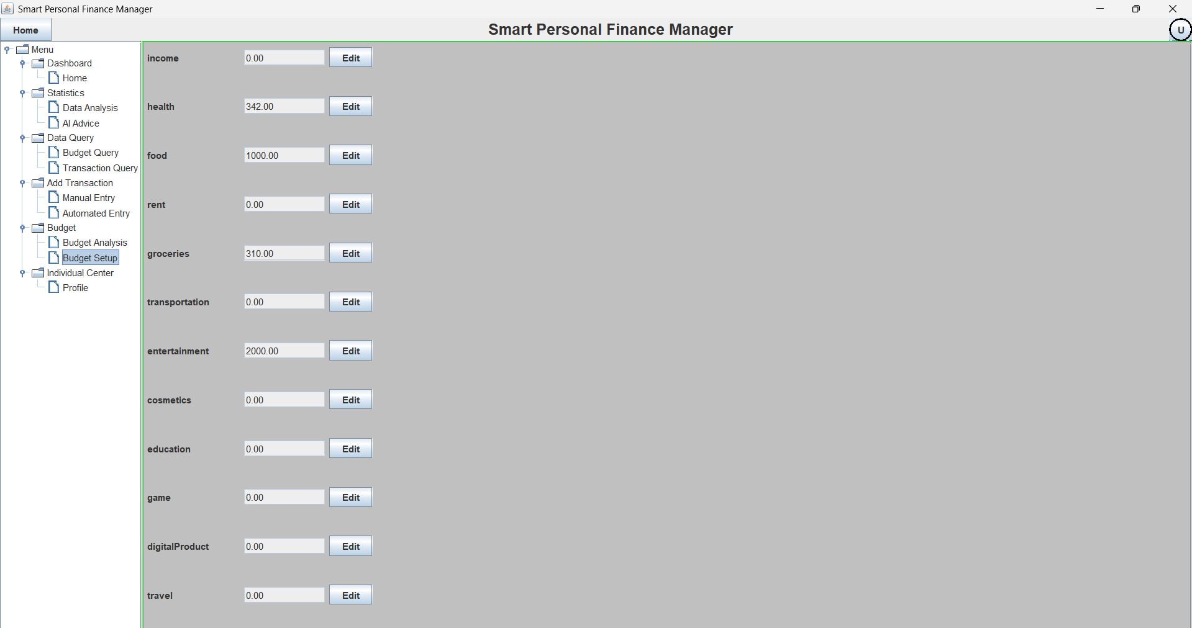
5. **Individual Center**
   * **Profile**: Allows you to edit the username, user ID, and change the login password.
   * 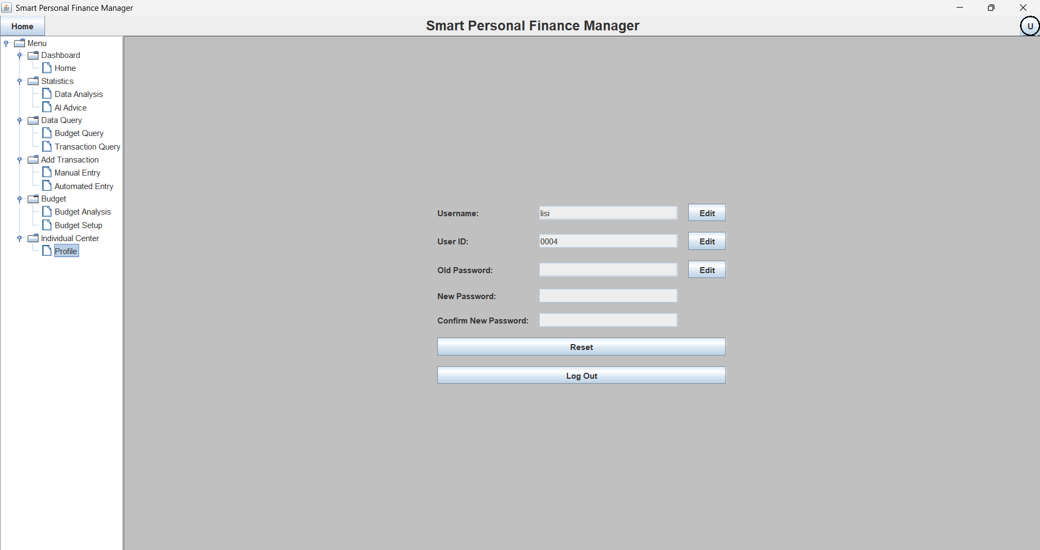

## 3. Function Usage Instructions

### (1) View Financial Overview

1. **Home View**: After logging in, on the home page, you can quickly obtain information about the consumption trends and structure of the past 7 days, understanding the consumption dynamics and key consumption areas.
2. **Statistics Information View**: On the "Statistics - Data Analysis" page, view the expenditure ranking to know the main consumption items; and through the monthly income and expense bar charts, compare the differences in income and expenses across different months.

### (2) Query Financial Data

1. **Budget Query**: On the "Data Query - Budget Query" page, enter conditions such as budget ID and date, or select the budget type, and click "Query" to obtain relevant budget records; click "Reset" to clear the conditions and query again.
2. **Transaction Query**: On the "Data Query - Transaction Query" page, set conditions such as date and owner, and click "Query" to view transaction records; after selecting a record, choose a new type in the "Change Type to" dropdown, and click "Modify Type" to change the transaction type.

### (3) Add Transaction Records

1. **Manual Entry**: Go to the "Add Transaction - Manual Entry" page, fill in the transaction amount, type (income or expense category), time, product name, location, and description in sequence, and click "Save" when done.
2. **Automated Import**: On the "Add Transaction - Automated Entry" page, click "Upload CSV" and select a file in the appropriate format to import transaction data.

### (4) Budget Management

1. **Budget Analysis**: On the "Budget - Budget Analysis" page, select the budget type, year, and month, view the historical budget comparison bar chart to understand the changes in budget amounts; view the budget distribution pie chart to grasp the budget distribution of the current month; view the budget - vs - actual - expenditure comparison line chart to evaluate the budget execution.
2. **Budget Setup**: On the "Budget - Budget Setup" page, click the "Edit" button after each category to modify the budget amount and set a reasonable budget.

### (5) Obtain Financial Advice

On the "Statistics - AI Advice" page, click the "Generate" button under different modules (such as general financial advice, budget analysis, etc.) to obtain professional advice based on your financial data and optimize your financial management.

### (6) Personal Information Management

On the "Individual Center - Profile" page, click "Edit" to modify the username and user ID; enter the old password, new password, and confirm the new password, then click "Reset" to change the password; click "Log Out" to exit the account.